**Customer Satisfaction and Brand Loyalty among Consumers for Brands of**

**Electronic Durables: A Study of Rural Areas of Doaba Region**

**A Report Paper**

**By**

**Jainab Siddiqui**

**Bachelor In Business Management (BBM)**

**Third Semester**

**Business Report Methods**

**Submitted to**

**Gautam Maharjan**

**Faculty of Management**

**Tribhuvan University**

**June, 2024**

**Abstract**

Maintaining and improving customer base is one of the basic areas for the marketers to look after. Enhancing brand loyalty provides an effective solution in this regard and more importantly in the segments where the level of competition is very severe like the electronic durables segment. Customer Satisfaction is an important antecedent of brand loyalty. This paper aims to find out the levels of customer satisfaction and brand loyalty among the customers of electronic durables in the rural areas of Doaba region. Three electronic durables have been considered in the study which are TV, Refrigerator and Washing Machine. The study highlights that as far as the brands of electronic durables are concerned the customers in the rural areas of Doaba region are well satisfied with them and exhibit a high degree of brand loyalty towards them.

**Introduction**

With the growing competition induced in almost all the product categories by the virtue of liberalization and globalization, a major question which almost all the marketers are facing is how to maintain and retain customer base to effectively support the operations of the organization. This has become rather a very challenging question keeping in view the huge range of product variety available with the customer and the limited resources available with the marketing managers. Managing all this hence becomes tough in view of the fierce competition. In all this situation the brand value of the organization plays a very important rather crucial role to help organizations survive and grow. The brand value of an organization is believed to be created out of satisfied customers and leads to loyal customers who ensure revenues even in tough times. This paper aims to empirically develop an understanding with regard to the levels of customer satisfaction among the customers of electronic durables in the rural areas of Doaba region and the brand loyalty of these customers towards their preferred brands. The study further makes an effort to find out and analyze the possible reasons responsible for the customers who were not brand loyal.

**Customer Satisfaction and Brand Loyalty**

Customers usually have in their mind a perception about product performance prior to their consumption. This perception becomes an essential and important determinant of their satisfaction after the use of the product. Kotler Philip et al (2015) has defined Customer Satisfaction as “a person‟s feeling of pleasure or disappointment after comparing a product‟s perceived performance or outcome against his/her expectations”. Customer Satisfaction hence can be regarded as an abstract phenomenon and depends upon factors like product quality and service quality associated with the product. Ross Beard (2014) through survey of 200 senior marketing managers found that 71 per cent of them found that a customer satisfaction metric to be very useful in managing and monitoring their businesses. He reported six reasons that induced a high level of importance with regard to customer satisfaction which were:

• It acts as a leading indicator of consumer repurchase intentions and loyalty.

• It acts as a point of differentiation.

• It helps to reduce the consumer churn.

• It enhances the customer lifetime value.

• It helps to control the negative word of mouth.

• It is cheaper to retain customers than to find new ones.

Hence it could be very easily concluded that the benefit that customer satisfaction gives to an organization is in terms of enhanced brand value and improved brand loyalty among the customers. PeterJ. Paul and OlsonJerry C.(2010) have defined Brand Loyalty as , “Brand Loyalty is an intrinsic commitment to repeatedly purchase a particular brand. It is differentiated from repeat purchase behavior because the latter focusses only on the behavioral action without concern for the reasons for the habitual response”. As per Martisiute Sandra et. al., Brand Loyalty or a loyal consumer is highly essential for an organization because of reasons below:

• It is cheap to maintain a loyal customer than finding a new one.

• It is easier to maintain a loyal consumer.

• The feedback of a loyal customer is usually positive leading to a favorable mouth to mouth communication.

Thus it can be concluded that customer satisfaction is highly important for any organization and it is by the virtue of customer satisfaction that brand loyalty is achieved which creates a favorable environment for the organizations to grow and prosper in the ever competitive markets.

**The Doaba Region**

The socio cultural division of Punjab state lying in between the rivers Satluj and Beas is referred to as the Doaba region of Punjab. The name Doaba finds its origin in the Persian word “Doab” which refers to the “land of two rivers”. The Doaba region of Punjab has not only got a rich cultural and social heritage but also has a strong historical presence in the historical background of Punjab. This region has played a major role in the early spread of Sikhism owing to its historic connections with Guru Nanak Dev and the travels of the fifth, sixth, seventh and the ninth guru of Sikh religion. Like the rest of the Punjab state this region as well is a predominantly rural in nature. The region constitutes of 24 major towns and has more than fifty-five hundred small and big villages. This region spreads across about nine thousand square kilometers and supports a population of more than four million, making it one of the most densely populated regions of the state. One important reason responsible for this being the economically well off status of this state which can be easily attributed to the large scale presence of families of people living in this region who had moved abroad and the remittances sent by them. It is perceived that people of Doaba region were among the first to migrate.

**Review of Literature**

For the purpose of developing a strong theoretical foundation with regard to the topic being

considered in the study and to develop a conceptual understanding a few studies in the similar directions have been reviewed. A brief description of these studies is given below:

**Dib Hayan and Al. Msallam Samaan (2015)** in their research attempted to explore the effect of perceived quality, brand image and price fairness on customer satisfaction and brand loyalty among mobile phone users. This study being based on primary data used data collected from a convenience and judgement sample of 584 respondents who were undergraduate students in major universities of Damascus. The study revealed that perceived quality, brand image and price fairness had a significant positive influence in building up of customer satisfaction which ultimately helped organizations to gain benefits in terms of brand loyalty.

**Krishna Nandan Lima and Suryati Lili (2015)** carried out a research to determine the partial and simultaneous influence of product quality price and brand image on customer satisfaction and loyalty. The study was based on data collected from 210 Honda Car buyers in Medan City (Indonesia). The study found that product quality, brand image and price of Honda Cars had a positive and significant influence on customer loyalty.The study found that while product quality and price of Honda cars were having negative but insignificant impact on customer loyalty, whereas brand image was having positive and significant impact on customer loyalty. The study further found that customer satisfaction was having influential positive as well as significant impact on customer loyalty.

**Awan Abdul Ghafoor and Rehman Asad Ul (2014)** carried out a study to analyze the impact of customer satisfaction over brand loyalty in case of durable goods. The study was based on primary data collected by means of a structured questionnaire from 300 middle class and business people households. The study helped to conclude the brand performance, a fundamental motivational factor for customer satisfaction had significant and positive impact on customer satisfaction and an improved customer satisfaction and brand value lead to brand loyalty. The study found that perceived decent product performance was key driver for brand loyalty and an important influences on customer satisfaction. The study indicated that organizations striving for brand loyalty should concentrate on customer satisfaction and brand performance.

**Ahmed Zahib et al. (2014)** through their research investigated the role of service quality, perceived quality and value over brand loyalty with brand trust and customer satisfaction acting as intervening variables. The study was based on primary data collected from a randomly selected sample of 150 Hewlett Packard customers in Bahawalpur (Pakistan) by using a self-administered questionnaire. The study helped to conclude that brand trust was the most important factor affecting brand loyalty followed by customer satisfaction. Both were having a positive and significant relationship with brand loyalty. The study further found that service quality and perceived quality is having positive effect on the intervening variables i.e. brand trust and customer satisfaction.

**Lee Jeonghaon and Lee Hansuk (2013)** carried out a research to examine whether the relationship between customer satisfaction and their behavioral brand loyalty was positive and also by using multidimensional approach they attempted to measure behavioral brand loyalty. A longitudinal survey was conducted in a span of two years by dividing legal respondents into 4 groups where loyalty was investigated as actual repurchase behaviour. The study helped to conclude that there existed a positive relationship between customer satisfaction and their behavioral brand loyalty. Further the study highlighted that more the level of satisfaction of the customer higher would be his loyalty.

**Nawaz Nool-Ul-Ain and Usman Ahmad (2013)** carried out a research to propose a model for brand loyalty and to test its potential antecedents in the mobile phone network market in Pakistan. The antecedents considered in the research were service quality, satisfaction, trust and commitment. The study helped to conclude that service quality satisfaction commitment and trust are important antecedents for brand loyalty. The study further found that service quality was the most important factor for brand loyalty among customers and also had a direct influence over customers with regard to brand loyalty. However, satisfaction had an indirect positive influence over brand loyalty.

**Demir Mehmet Ozer et al. (2013)** carried out an explanatory research using Structural Equation Models. Study was based on primary data collected by means of a structured questionnaire from 300 consumers residing in Antalya, Turkey. The study concluded that customer satisfaction directly affected commitment whereas it had an indirect impact over the brand loyalty. The study also found that commitment had a direct effect on brand loyalty.

**Kiyani Talat Mohamood et al. (2012)** in their research analyzed the relationship between brand trust, customer satisfaction and customer loyalty through a primary study by collecting data from 131 respondents through a self-administered questionnaire in twin cities of Islamabad and Rawalpindi of Pakistan. The study was carried out for the automobile sector. The study found that there existed positive and significant relationship between of customer loyalty with both brand trust and customer satisfaction. It was found that customer satisfaction led to loyalty and its role was comparatively more important than brand trust in building customer loyalty. Customer satisfaction also led to development of brand trust.

**Shirin Artyom and Puth Gustav (2011)** tried to find out the direct and indirect effects of customer satisfaction, perceived value, trust and variety seeking on brand loyalty. For the purpose they tested a model in this regard which might be seen as an extension of the American/European customer satisfaction index (CSI) model. The study helped to conclude that all the constructs considered in the study i.e. customer satisfaction, perceived value and brand trust had a strong relationship with attitudinal brand loyalty. The study also found that the behavioral loyalty predictor was affected by attitudinal loyalty. It was further concluded in the study that variety seeking behaviour was an important determinant for behavioral loyalty as well as switching intention of the customers.

**Martisiute Sandra etal. (2010)** carried out an analytical study on the basis of various research works to verify the link between brand satisfaction and customer loyalty. The study helped to conclude various aspects with regard to satisfaction and loyalty. Some of these aspects were: -

- Cognitive loyalty of customers is related to fundamental characteristics of product whereas emotional loyalty with brand and action loyalty implies that customer is brand loyal.

- Customer satisfaction resulted into their loyalty and also it was found to be essential for

loyalty.

- Customers loyalty and satisfaction can be improved overtime.

**Martensen Anme (2007)** carried out a research among young consumers aged between 8-12 years to find out the strength in relationship between satisfaction and loyalty. The product considered in the study was mobile phone and around 1000 respondents from 35 schools in the Greater Copenhagen area were interviewed for the collection of data. The analysis of the data revealed that for tweens (children aged between 8-12 years) the level of satisfaction was high for their mobile phones as these were able to fulfil their expectations but still this high level of satisfaction was not converting them into loyal customers. The study further revealed that in case of tweens the relationship between satisfaction and loyalty was weak as compared to adults.

**Taylor Steven A. et al. (2004)** in their research study empirically tested a research model for ascertaining the antecedents of customer loyalty both behavioral as well as attitudinal for industrial customers of heavy equipment manufacturers. The study helped to conclude that for both behavioral and attitudinal loyalty the most important and consistent antecedents were brand equity and trust. Other important antecedents included satisfaction, value affect and resistance to change. Keeping in view the above mentioned studies the present study carried out is an attempt to satisfy the below given objectives.

**Objectives of the Study**

The current study has been carried out with the aim to satisfy the following objectives:

1. To develop an understanding with regard to level of satisfaction among the rural consumers of Doaba region with regard to the brand purchased of electronic durables.
2. To develop an understanding with regard to the levels of brand loyalty among the rural

consumers of Doaba region for brands of electronic durables.

1. To develop an insight into the reasons given by the rural and urban customers of Doaba

region for not being brand loyal.

**Research Methodology**

This research is based on primary data collected from 250 respondents of rural areas of Doaba region. These respondents for the study have been selected by means of judgment sampling from the rural areas of the region. The number of respondents have been considered proportionately on the basis of total population of rural areas of that district and the total rural population of Doaba region as per Census 2011. The number of respondents hence were calculated for each district by applying the following formula:



The numbers so obtained were rounded off to the nearest tens as shown in Table 1

|  |  |
| --- | --- |
| **District** | **Number of Respondents** |
| Hoshiarpur | 90 |
| Jalandhar | 80 |
| Kapurthala | 40 |
| Nawanshahr | 40 |
| **Total** | **250** |

The respondents were served a pre-designed, well structured, pre tested closed ended questionnaire and the responses were obtained by personally interviewing the respondents. The respondents considered in the study belonged to different age groups, gender, occupation, education level and annual income level. The respondents considered in the study were from both nuclear as well as joint families and were having distinct family sizes. However, only one person from the family was considered in the study. The data collected was analyzed by means of simple frequencies, percentages and weighted average scores.

**Data Analysis**

To develop an insight with regard to the level of satisfaction of the customers for the presently owned brands of TV, Refrigerator and Washing Machine, the respondents were asked to rate their level of satisfaction on a five-point satisfaction scale. The analysis for this has been carried out by taking the sum of products of the weightages given by the respondents with the number ofrespondents and the total score thus obtained has been divided by the number of respondents to

obtain the weighted average score. The scores so obtained are displayed in the following table:

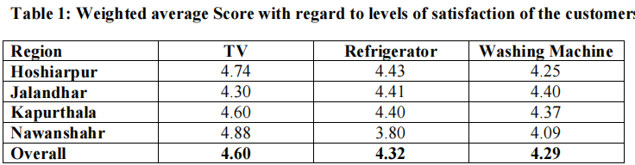

The data in the table above depicts clearly that most of the customers of all the four districts are satisfied with their presently owned brands of all the three product categories. The data reveals that the level of satisfaction is highest for the brands of TV followed by refrigerator and Washing Machine. In case of TV the data suggests that the highest level of satisfaction is in Nawanshahr district followed by Hoshiarpur, Kapurthala and Jalandhar. For Refrigerator, the highest level of satisfaction is in Hoshiarpur district followed byJalandhar, Kapurthala and Nawanshahr and in case of Washing Machine the highest level of satisfaction is for Jalandhar district followed by Kapurthala, Hoshiarpur and Nawanshahr. Attitude Brand Loyalty refers to the consumer‟s feeling of commitment for a particular brand. To check the level of attitude brand loyalty of the respondents the respondents were asked that in case of future purchase of the three durables considered in the study i.e. TV, Refrigerator and Washing Machine will they go ahead with the same brand or would they like to try some other brand. The responses obtained in this regard for all the three durables are summarized in Table 2 to Table 4 The data presented in Table 2 indicates that for TV more than 80 per cent of respondents have indicated that they would continue with the same brand in case of any future purchase of TV. There were marginal differences in this regard among the respondents of the four districts with the maximum number of respondents affirming to continue with the samebrand from Kapurthala and Nawanshahr both having 85 per cent of such respondents followed by Hoshiarpur (85.6%) and Jalandhar (78.8%).

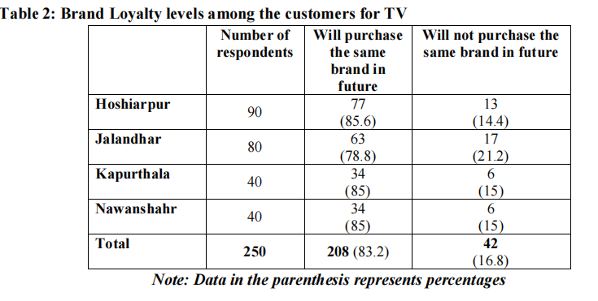

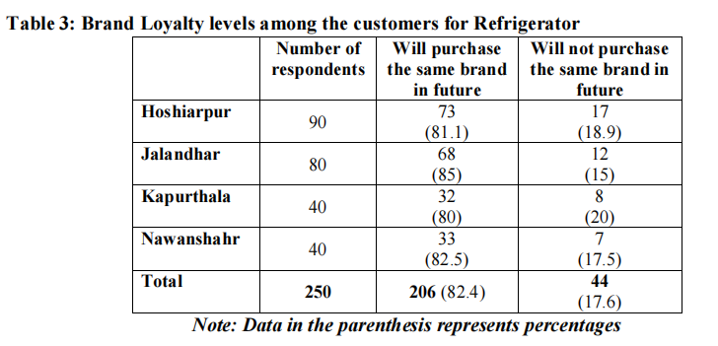

In Table 3 the data suggests that more than 80 per cent of the respondents are indicative that they will continue with the same brand of refrigerator in case of any future purchase. The differences in this regard were very minute in case of the respondents of all the four districts. However, the leading district in this case is Jalandhar (85%) followed by Nawanshahr (82.5%), Hoshiarpur (81.1%) and Kapurthala (80%).

**Table 4: Brand Loyalty levels among the customers for Washing Machine**

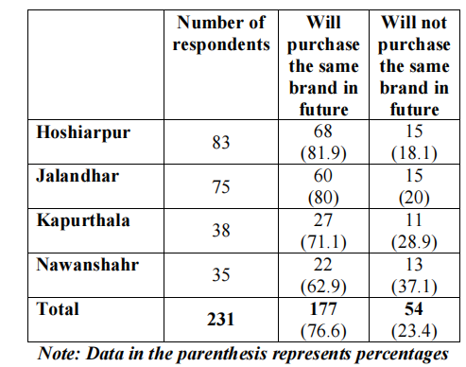

The data in Table 4 indicates that the respondents who are indicative of purchasing the same brand again are 76.6 per cent.As far as their district wise position is concerned the data suggests that the brand loyalty is highest in case of Hoshiarpur (81.9%) followed closely by Jalandhar (80%). However, there is a sudden decrease in the levels of brand loyalty in case of Kapurthala (71.1%) and Nawanshahr (62.9%). The attitude Brand Loyalty of the respondents was further tested by asking the respondents that in case their preferred brand is temporarily not available in the market then what would be their preferred course of action from the three options provided to them i.e. would they buy some other brand (indicating they are not brand loyal), would they look out for the same brand from some other store (indicating brand loyalty but indicating a behaviour that they are not going to be store loyal) and wait for the preferred dealer to get stock (indicating brand as well as store loyalty). The results obtained in this regard are presented in Table 5.

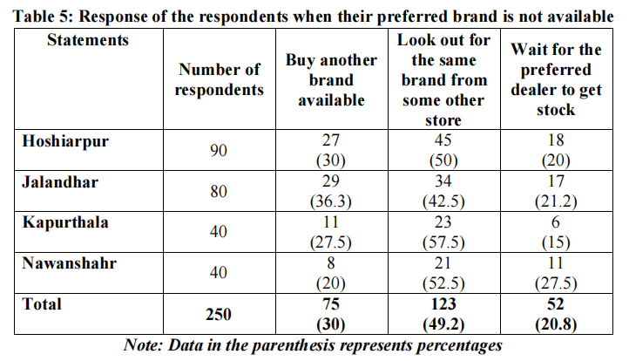

The data in the table suggests that about 50 per cent of the respondents are brand loyal and are expressing that they would look out for the same brand in some other store in case their preferred brand is not available in their preferred store. As far as brand loyalty along with store loyalty is concerned 20.8 per cent respondents are in this category. The respondents who are not brand loyal and are going to look for some other brand in case their preferred brand is not available constituted about 30 per cent. District wise the data indicates that in case brand loyalty and store loyalty are taken together the leading district is Nawanshahr (52.5% brand loyal and 27.5% brand as well as store loyal) followed by Kapurthala (57.5% brand loyal and 15% brand as well as store loyal), Hoshiarpur (50% brand loyal and 20% brand as well as store loyal) and Jalandhar (42.5% brand loyal and 21.2% brand as well as store loyal). The small number of respondents who were found not to be brand loyal were further asked to select the possible reasons for them being not brand loyal. They were required to select from a set of eight possible reasons for them being not brand loyal. The reasons marked by the respondents are tabulated as below:

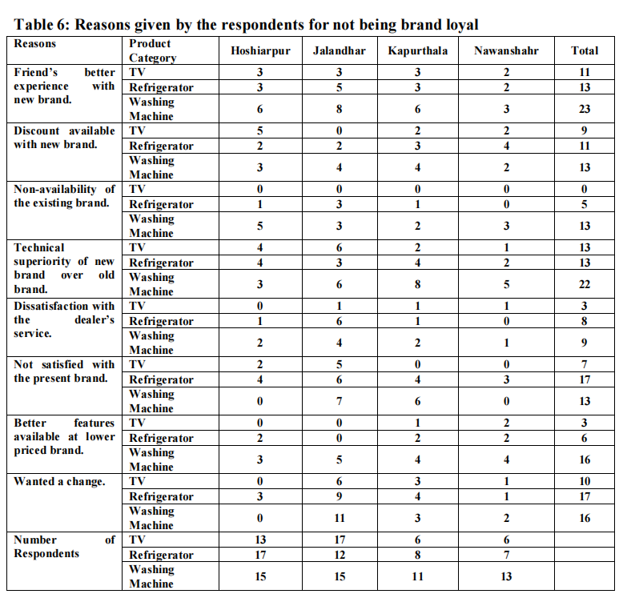

The data presented in the table above reveals that the most important reason on the basis of number of times the reason is reported by the respondents for switching brands in case of TV is „Technical superiority of new brand over old brand‟ followed by „Friend‟s better experience with the new brand‟, „Discount available with new brand‟ and „Not satisfied with the present brand‟. In case of Refrigerator, the most important reason on the basis of number of times the reason is reported by the respondents for switching brands is „Not satisfied with the present brand‟ followed by „Wanted a change‟, „Friend‟s better experience with the new brand‟, „Technical superiority of new brand over old brand‟ and „Discount available with new brand‟. In case of Washing Machine, the most important reason on the basis of number of times the reason is reported by the respondents for switching brands is „Friend‟s better experience with the new brand‟ followed by „Technical superiority of new brand over old brand‟, „Better features available at lower priced brand‟, „Wanted a change‟, „Not satisfied with the present brand‟, „Discount available with new brand‟ and „Non availability of the existing brand‟. The data further reveals that the maximum number of responses have been obtained for Washing Machine followed by Refrigerator and TV.

**Findings**

The major findings of the study are:

1. For most of the respondents across all the four districts considered in the study their level of satisfaction is on a higher side for all the three durables considered in the study. Individually for the three product categories the level of satisfaction is highest for brands of TV followed by Refrigerator and Washing Machine.
2. With regard to the attitudinal brand loyalty levels of the respondents it was found that its level is high among the respondents for all the three product categories considered in the study. However, its levels are found to be the highest in case of TV followed by Refrigerator and Washing Machine.
3. In response to the respondents course of action incase their preferred brand is not available temporarily in the market, a huge majority of respondents displayed a high degree of attitudinal brand loyalty for all the four districts considered in the study by displaying a high degree of brand loyalty or brand loyalty along with store loyalty.
4. With regard to the reasons reported by the respondents for not being brand loyal it has been found that the reasons reported by the respondents for not being brand loyal were different for each of the product category. In case of TV the most important reason given by the respondents for not being brand loyal is „Technical superiority of new brand over old brand‟ in case of Refrigerator it is „Not satisfied with the present brand‟ and for Washing Machine it is „Friend‟s better experience with the new brand‟.

**Conclusion**

The present research was intended to examine the relationship between brand satisfaction and customer loyalty in case of three specific electronic durables i.e. TV, Refrigerator and Washing Machine in the rural areas of Doaba region. It was found that the level of satisfaction among the customers with their presently owned brand is high and this could be the possible reason for a high degree of brand loyalty displayed by the customers reiterating that customer satisfaction has an influential positive and significant impact on customer loyalty similar to the results of a study conducted by Suryati Lili and Krisna Nandan Lima (2015). As far as the individual product categories are concerned the highest level of customer satisfaction with the presently owned brand was with regard to TV and lowest in case of Washing Machine and accordingly it was found that highest level of brand loyalty is in case of TV and lowest for Washing Machine. An exploration into the reasons reported by the customers who were not brand loyal found that the reasons reported by them are varied for each category of consumer durable.

**References**

Ahmed, Z., Effect of brand trust and customer satisfaction on brand loyalty in Bahawalpur. *Journal of Sociological Research, 5*(1), 306-326.

Awan A. G., & Rehman, A. (2014). Impact of Customer Satisfaction on Brand Loyalty: an Empirical Analysis of home appliances in Pakistan. *British Journal of Marketing Studies*, *2*(8),18-32.

Back, K.J.(2001). *The Effects of Image congruence on Customer Satisfaction and Brand Loyalty in the Lodging Industry,* The Pennsylvania State University.

Chandio, Z. U., Qureshi, M. A., & Ahmed, S. (2005). Brand Trust, Customer Satisfaction and Brand Loyalty-A Cross Examination, *Journal of Business Strategies, 9*(1), 63–82.

Delgado, B. E., Munuera, A., & Jose, L. (2001). Brand trust in the context of consumer loyalty, *European Journal of Marketing; 11/12*, 1238-1258.

Demir, M. Ö., Yüzbaşioglu, N., & Bezirci, M. (2013). A review of the relationship between brand loyalty, customer satisfaction and commitment using structural equation modeling within the internal control process, *African Journal of Business Management,7*(13), 1067-1078.

Dib, H., & Al, M. S. (2015). The Effects of the Determinants of Customer Satisfaction on Brand Loyalty, *Quest Journals, Journal of Research in Business and Management,* *3(3)*,2347-3002.

Ha ,H.Y., Janda ,S., & Park, S.K.(2009).Role of satisfaction in an integrative model of brand loyalty Evidence from China and South Korea. *International Marketing Review*. *26* (2),198-220.

Kiyani, T. M. & Niazi, M. R. U.K.(2012).The relationship between Brand Trust, Customer Satisfaction and Customer Loyalty :Evidence from Automobile Sector of Pakistan. *Interdisciplinary Journal of Contemporary Research in Business, 4*(1), 489-502.

Kotler, P. et al. (2015), *Principles of Marketing*, Pearson Education Inc.

Lee, J.,& Lee, H.(2013). Does Satisfaction affect Brand Loyalty. *Academy of Marketing Studies Journal* *17*(2), 133-147.

Martensen, A.T. (2007). Satisfaction and Brand Loyalty in the Mobile Phone Market. *Young Consumer*,*8*(2), 108-116.

Martisiute, S. et al.(2010). Product or Brand: How Interrelationship between Customer Satisfaction and Customer Loyalty Work. *European Journal of Interdisciplinary Studies, 2*(1), 5-15.

McAlexander, J. H., Kim, S. K.,& Roberts, S. D.(2003). Loyalty: The influences of Satisfaction and Brand Community Integration. *Journal of Marketing Theory and Practice, 11*(4), 1-11.

Nawaz, N.U.A.,& Usman ,A.(2013). What Makes Customers Brand Loyal: A Study on Telecommunication Sector of Pakistan. *International Journal of Business and Social Science,* *2*(14), 213-221.

Peter, J. P.& Dilson, J. C. (2010). *Consumer Behaviour and Marketing Strategy*. Tata McGraw- Hill, New Delhi.

Selnes, F.(1993). An examination of the effect of product performance on brand reputation, satisfaction and loyalty. *European Journal of Marketing ProQuest Central*, *27*(9),19- 35.

Shirin ,A. & Puth, G.(2011). Customer satisfaction, brand trust and variety seeking as determinants of brand loyalty. *African Journal of Business Management,5(*30),11899-11915.

Suryati, L.& Krisna, N. L.(2015). Determinants of Customer Satisfaction and its implication on Customer Loyalty :the Empirical study of Automotive Customer in Medan. *IJABER*,*13*(7), 5045-5066.

Taylor, S. A., Celuch, K., & Goodwin, S.(2004).The importance of brand equity to customer loyalty. *The Journal of Product and Brand Management,13*(4/5) ,217-227.

Walter ,N. et al.(2013). Brand Experience's influence on Customer Satisfaction and Loyalty: A mirage in Marketing Research. *International Journal of Management Research and Business Strategy*,*2*(1), 130-144.

**The Study of Customer Satisfaction inService**

**Quality Towards Kandawgyi Palace Hotel,**

**Yangon, Myanmar**

Miss Eaindrae Maung Maung1 , Dr. Vijit Supinit 2

MBA, Siam University, Thailand

**Abstract**

To sustain in the hotel industries especially for long lasting and have competitive advantage over others should have to find different alternatives to maintain customer satisfaction and to accomplish it hotel industries should focus on its key factors that enable them to increase the customer satisfaction and customer retention. This research paper identifies service quality, perceived value and customer expectation as vital factors affecting customer service. Quality of service and customer satisfaction are critical factors for success of any business (Gronoos, 1990; Parasuraman et al., 1988). As Valdani (2009) points out: enterprises exist because they have a customer to serve. The key to achieve sustainable advantage lies in delivering high quality service that results in satisfied customers (Shemwell et al, 1998). The main purpose of this study is to study the guest’s responses at kandwagyi palace hotel Yangon, Myanmar and the results of this study can provide the wide variety of different alternative to tackle the customer demands and needs. After completion of all data analysis the researcher found out that there is a strong relationship between dependent variables (Perceived value, service quality and customer expectation) and independent variables (customer satisfaction) and three hypotheses proved that there is a strong relationship and accepted the relevant relationship, data collected were correct and significant. In addition, the relationship between customer demands and expectation could also be conducted and use of different statistical method to analyze the test between service quality and customer satisfaction. This research work can also be applied to different sector as well such as manufacturing sector, marketing and aviation sector. *Keywords:* Service quality, perceived quality, customer expectation, customer satisfaction**.**

**1. INTRODUCTION**

The Kandawgyi Palace Hotel is located in the downtown of Yangon, Myanmar and has 119 rooms, all of which are equipped with a spa bath and a shower that targets local and tourist around the world by retaining the traditions of Myanmar architecture using local golden teak and modern conveniences blend with the beautiful environs of the lake, gardens and original old rainforest make our Hotel the preferred destination in Yangon, Myanmar for both discerning business travelers and tourists alike. Rooms are pleasantly designed with wooden floors and international facilities. At present, hotel visitors in Myanmar seem to have high standards and demands for excellent service. The hotels have increased their competition and now instead of having only a nice room to draw customers in, they offer -high quality staff. As an amenity as well. Guest satisfaction is the highest priority for owners and managers competing with hundreds of others, and personal service is at the top of the travelers& list of the most important things when considering a hotel to stay in (Wipoosattaya, 2001).

In order to achieve customer satisfaction, it is important to recognize and to anticipate customers' needs and to be able to satisfy them. Enterprises which are able to rapidly understand and satisfy customers' needs, make greater profits than those which fail to understand and satisfy them (Barsky & Nash, 2003). Since the cost of attracting new customers is higher than the cost of retaining the existing ones, in order to be successful managers must concentrate on retaining existing customers implementing effective policies of customer satisfaction and loyalty. This is especially true in the hotel industry. Customer requirements for quality products and service in the tourism industry have become increasingly evident to professionals (Lam & Zhang, 1999; Yen & Su, 2004). Guest relationships are a strategic asset of the organization (Gruen et al., 2000) and customer satisfaction is the starting point to define business objectives. In this context, positive relationships can create customer’s higher commitment and increase their return rate. Long-term and reciprocally advantageous relationships between customers and the hotel is becoming progressively important because of the highly positive correlation between guests' overall satisfaction levels and www.ccsenet.org/ijms International Journal of Marketing Studies Vol. 2, No. 2; November 2010 4 ISSN 1918-719X E-ISSN 1918-7203 the probability of their return to the same hotel (Choi & Chu, 2001). Hotels are increasing their investments to improve service quality and the perceived value for guests so as to achieve better customer satisfaction and loyalty, thus resulting in better relationships with each customer (Jones et al., 2007). Relationship quality has a remarkable positive effect on hotel guests’ behavior: it creates positive word of mouth (WOM) and increments repeated guest rates (Kim et al., 2001).

This research studies the customer satisfaction and loyalty toward Kandawgyi Palace hotel in Yangon, Myanmar in view of an interesting case study that can use the result obtained for a service development and improvement in the future.

**2. LITERATURE REVIEW AND CONCEPTUAL FRAMEWORK**

**CONCEPTUAL FRAMEWORK:**

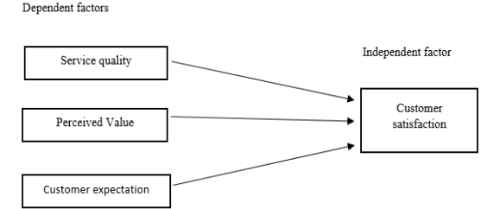

**Hypothesis mentioned:**

H1: Service quality has a direct impact on customer satisfaction in hotel industry

H2: Perceived value has a direct relationship with customer satisfaction

H3: Customer Expectations has a direct influence on customer satisfaction in hotel Industry.

The research problem in this paper was how Kandawgyi Palace Hotel to survive in the market to attract customers over its competitors such as in Yangon such as Sedona Hotel Yangon, Chatrium Hotel Royal Lake Yangon, Savoy Hotel, PARKROYAL Yangon, The Stand Yangon, and Anantara (being constructed) are strongly competing with five-star hotel chains. This paper also outlined how Kandawgyi Palace hotel can retain its customer over other by influencing the three major factors such as Service quality, Perceived value and customer expectation.

Furthermore, this study had to assessed the customer satisfaction towards service quality at Kandawgyi Palace hotel because it would be beneficial for the hotel industry to learn different innovative ways to attract and retain their customers and also by providing important training platforms to their staffs so that they perform better which can cause the increment in customer visits.

**LITERATURE REVIEW:**

**Customer satisfaction**

Customer satisfaction is a business philosophy which tends to the creation of value for customers, anticipating and managing their expectations, and demonstrating ability and responsibility to satisfy their needs. Qualities of service and customer satisfaction are critical factors for success of any business (Gronoos, 1990; Parasuramanetal., 1988). As Valdani(2009) points out: enterprises exist because they have a customer to serve. The key to achieve sustainable advantage lies in delivering high quality service that results in satisfied customers (Shemwellet al, 1998).

Kotler (1999) was the pioneer of generating the term customer satisfaction in business and marketing. Researchers have introduced numerous explanations for customer satisfaction. Vanacore and Etro (2002) proposed customer satisfaction as the general assessment, which is done by customers about specific product or service at a certain time. A particular instance of theories that has a significant influence on customer satisfaction is the Expectancy Disconfirmation Theory that is discussed enormously in customer satisfaction literature. This theory illustrates the pros and cons about changeability based on the perception of purchasing a product or service before them bargain. Presence of service also could be justified based on satisfaction and dissatisfaction. Zeithaml and Bitner (2003) discussed that dissatisfaction appears when the customers experience significant difference between their expectations and the quality of services that they receive. Vanacore and Erto (2002) believe that the main precursor of customer satisfaction includes expectations, perceived quality, and disconfirmation. American Customer Satisfaction Index (ACSI) is a sample of appropriate customer satisfaction model. This specific model consists factors of variables of customer loyalty, perceived value, perceived service quality, customer expectations and customer complaints.

**Service quality:**

Service quality is the result of the comparison that customers make between their expectations about a service and their perception of the way the service has been performed (Gronroos, 1984; Parasuraman et al., 1985, 1988). A number of experts define service quality differently. Parasuraman et al. (1985) define it as the differences between customers, expectation of services and their perceived service. If the expectation is greater than the service performance, perceived quality is less than satisfactory and hence, customer dissatisfaction occurs. Lewis and Mitchell (1990), Dotchin and Oakland (1994), and Asubonteng et al. (1996) define service quality as the extent to which a service meets customers, need and expectation.

**The SERVQUAL approach:**

The SERVQUAL approach has been applied in service and retailing organizations (Parasuraman et al., 1988; Parasuraman et al., 1991). Service quality is a function of repurchase customers, expectation, perceived process quality, and perceived output quality. Parasuraman et al. (1988) define service quality as the gap between customers, expectation of service and their perception of the service experience.

**Perceived value:**

The perceived value has been examined by various authors as factor which has a great influence on the decisions making process of customers. Reviewed literature suggests that the perceived value of customer play a significant role in determining customer satisfaction, decision making and purchase behaviors (Kuo, Wu and Deng, 2009; Reid, Pullins, and Plank, 2002). In addition, the reviewed study on perceived value indicates that perceived value is considered as a significant element in affecting consumers’ consumption and decision making behaviour (Kuo, Wu and Deng, 2009; Eggert & Ulaga, 2002; Reid, Pullins, and Plank, 2002; Cronin, Brady, & Hult, 2000). Among these notions, Customer perceived value can be described as the evaluation of comparing the perception of typical perceived value and real outcome of purchase experience.

**Customer expectation:**

Customer expectations are beliefs of an individual about service performance before they receive the actual service delivery (Zeithaml et al., 2006, P. 81). In evaluating service quality, it is a comparison of customer’s expectation with the actual performance of service, and the different between customer expectations and perceptions of service is the “customer gap” in which a firm needs to close that gap (Bateson, 1995, P. 559; Zeithaml et al., 2006, P. 33). Moreover, the expectations and perceptions of customers are dynamic and constantly change over the time, so a firm must be continuously examining any changes to make an improvement quickly (Palmer & Cole, 1995, P.152; Zeithaml et al., 2006, P.33).

Davidow and Uttal (1989) proposed that customers, expectation is formed by many uncontrollable factors which include previous experience with other companies, and their advertising, customers, psychological condition at the time of service delivery, customer background and values and the images of the purchased product.

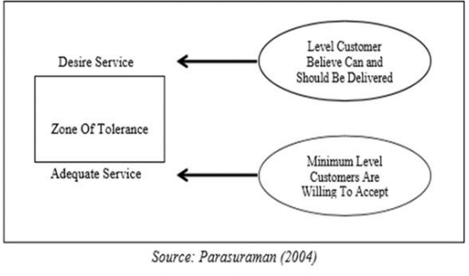

**Zone of tolerance of service expectation**

**Disconfirmation theory*:***

Disconfirmation theory was declared that satisfaction is mainly defined by the gap between perceived performance, expectations and desires which is a promising approach to explain satisfaction. This theory was proposed that satisfaction is affected by the intensity (or size) and direction (positive or negative) of the gap (disconfirmation) between expectations and perceived performance (Figure 2)

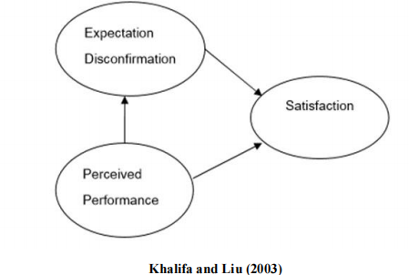

Expectation disconfirmation occurs in three forms:

1) Positive disconfirmation: occurs when perceived performance exceeds expectations.

2) Confirmation: occurs when perceived performance meets expectations.

3) Negative disconfirmation: occurs when perceived performance does not meet and is less than the expectations.

**3. METHODOLOGY**

The American Marketing Association defined marketing research as “the function with link the consumer, customer and public to marketer through information- information used to identify and define marketing opportunities and problems; generate, refine, and evaluate marketing actions; monitor marketing performance; and improve understanding of marketing as a process” (as cited in Parasuraman et al., 2004, P.8).

Research is a key tool for findings what customer want and how to satisfy their needs (Zikmund, 1997, P. 55) including understanding consumer expectations and perceptions of goods and services (Bateson, 1995, P.558: Zenithal et al., 2006, P.142) and linking consumer to marketer in making marketing decision (Burns & Bush, 2005, P.8).

**Research method:**

The research method used in this study was based on quantitative approach to gather primary data. There are many type of quantitative research; however, this study used the survey research via questionnaire to collect the data about attitudes of current customer at Kandawgyi Palace Hotel, Yangon. In order to obtain data for the calculation of explicit and implicit importance, as well as the level of customer satisfaction, this study used questionnaires as a tool to get responses from the subjects. The questionnaires were sent to their rooms upon arrivals, to rate the performance of the proposed quality attributes after there make use of the services in hotel, and also rating, in multiple item.

**Population and sampling:**

According to the purpose of this study, the target population of this research is customers who prior experience with Kandawgyi Palace Hotel, Yangon. Jackson (2008) suggested that a researcher can use a simple random sampling technique for selecting a sample that has an equal chance to be selected. It was estimated that Kandawgyi Palace Hotel, Yangon had about 250 persons of monthly customers. Therefore, this amount of customer was considered as population of the research.

In determining the sample size at Kandawgi Palace Hotel, there are several methods, however, selecting sample size in this research was based on the guidance of Naumann & Giel (1995) that present an appropriate sample size requirements regarding to population size shown in table (3.2.1.). The sample size for this study was 169

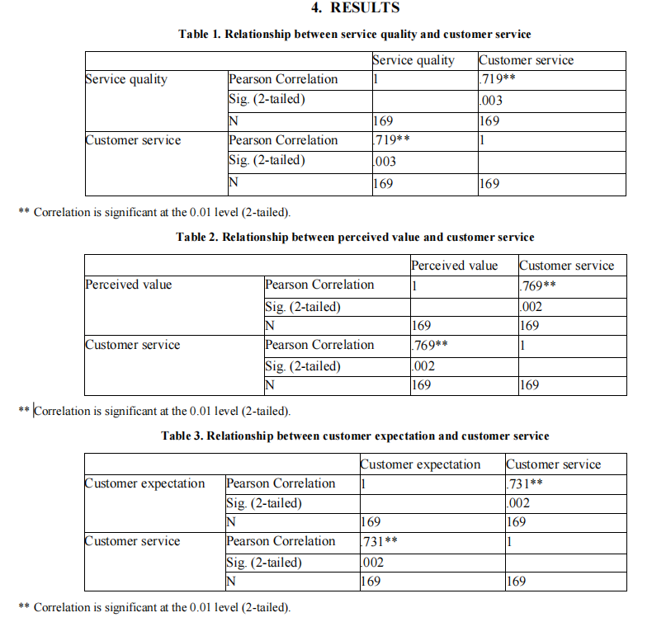

It’s confirmed that all the question is related in the same direction to determine same objectives of data analysis and according to the results arrived its concluded that with .819 of cronbach’s alpha reliability statistics accounted as “good” reliability test based on 25 questions.

**Relationship between service quality and customer service:**

From the results achieved in correlation table, it has been found out that the relationship between the service quality and customer service have strong relationship (.719**) as because correlation value is lower 0.03 and it explains that it’s below the level 0.05 margin error therefore the hypothesis H1 is accepted and there is a positive correlation between independent factors (service quality) and dependent factors (customer service).

**Relationship between perceived value and customer service:**

From the results achieved in correlation table, it has been found out that the relationship between the perceived value and customer service have strong relationship (.769**) as because correlation value is lower 0.02 and it explains that it’s below the level 0.05 margin error therefore the hypothesis H1 is accepted and there is a positive correlation between independent factors (perceived value) and dependent factors (customer service).

**Relationship between customer expectation and customer service:**

From the results achieved in correlation table, it has been found out that the relationship between the service quality and customer service have strong relationship (.731**) as because correlation value is lower 0.02 and it explains that it’s below the level 0.05 margin error therefore the hypothesis H1 is accepted and there is a positive correlation between independent factors (customer expectation) and dependent factors (customer service)

**5. CONCLUSIONS**

The study of customer satisfaction in service quality is a very important topic to be researched on as its provide the different variables to research for graduating students and enable them to know about their country economy and investment prospects. In order to go for detailed research students should know about how to achieve customer satisfaction, it is important to recognize and to anticipate customers' needs and to be able to satisfy them. Enterprises which are able to rapidly understand and satisfy customers' needs, make greater profits than those which fail to understand and satisfy them. As we know that the cost of attracting new customers is higher than the cost of retaining the existing ones, in order to be successful managers must concentrate on retaining existing customers implementing effective policies of customer satisfaction and loyalty. Therefore to compete with the competitors in hospitality sector and that can be achieved only by understanding different variables which provide high customer satisfaction in hotel industry to grow.

This research was mainly focused on customer satisfaction in service quality and emphasized on three main dependent variables to prove the independent variable.

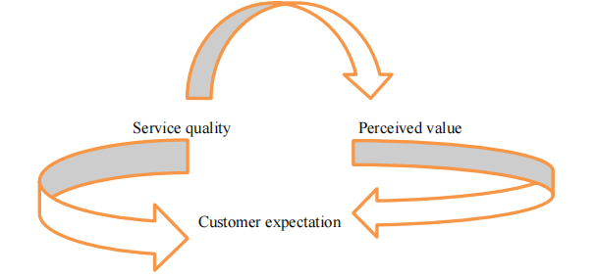

The aim of this independent study is to gather opinions of customers who experience in the service of Kandawgyi Palace Hotel and to achieve a better understanding of how the customer perceive and experience to the service provided. These are based on 6 dimensions of SERVQUAL tools including: Tangibles, Reliability, Responsiveness, Assurance, Empathy and customer satisfaction which are served as 6 criteria for making a judgment about quality of provided services by hotel guests.

**REFERENCES**

Anderson, E.W. & Fornell, C. (1994). *A Customer Satisfaction Research Prospectus in Service Quality: New Directions in Theory and Practice, Thousand Oaks, CA*. Sage Publications, Inc., 241-268.

Barsky, J. (1992). Customer Satisfaction in the Hotel Industry: *Measurement and Meaning. Cornell H.R.A., 7,* 20- 41.

Bitner, M.J., Booms, B.H. & Tetreault, S. (1990). The Service Encounter: Diagnosing Favorable and Unfavorable Incidents*. Journal of Marketing, 54*, 71-84.

Bitner, MJ. & Huber, A.R. (1993). Encounter Satisfaction Versus Overall Satisfaction Versus Quality, in The Service Quality Handbook, E.E. Scheuing & W.F. Christopher, eds. New York: *American Management Association*, 72-94.

Boland D., Morrison, D., & O’Neil, S. “The Future of Airline CRM” IBM Institute for Business Value (2002).

Bolton, R.N. (1994). *Linking Customer Satisfaction to Loyalty and Revenues*. Working paper, GTE Laboratories Inc.

Boulding, W., Staelin, R., Kalra, A. & Zeithaml, V. (1993). A Dynamic Process Model of Service Quality: From Expectations to Behavioral Intentions*. Journal of Marketing Research, 30*, 7-27.

Bowen, J.T. & Chen, S.L. (2001). The Relationship Between Customer Loyalty and Customer Satisfaction*. International Journal of Contemporary Hospitality Management, 13*, 213.

Buttle, Francis*. Customer Relationship Management*. Elsevier: n.p., 2004.

Ekinci, Y. (2002). A Review of Theoretical Debates on the Measurement of Service Quality: Implications for Hospitality Research. *Journal of Hospitality & Tourism Research*, *26*(3), 199-216.

Faullant, R., Matzler, K. & Füller, J. (2008). The impact of satisfaction and image on loyalty: the case of Alpineski resorts. *Managing Service Quality*, *18*(2), 163-178.

Frochot, I. & Hughes, H. (2000). HISTOQUAL The development of a historic houses assessment scale. *Tourism Management, 21*(2), 157-167.

Fu, Y.Y. & Parks, S.C. (2001). The relationship between restaurant service quality and customer loyalty among the elderly. *Journal of Hospitality and Tourism Research*, *25*(3), 320-336.

González, M. E. A., Comesana, L. R. & Brea, J. A. F. (2007). Assessing tourist behavioral intentions through perceived service quality and customer satisfaction. *Journal of Business Research, 60,* 153-160.

Greenberg, Paul. *CRM at the speed of light. Osborne*, U.S.A.: n.p., 2002. Giese, J.L. & Cote, J. A. (2000). Defining Customer Satisfaction. *Academy of Marketing Science Review. Reprieved July 18, 2007,* http://www.amsreview.org/articles/giese01-2000.pdf.

Grönroos, C. (1982). *Strategic Management and Marketing in the Service Sector*. Cambridge: Marketing Science Institute.

Grönroos, C. (1984). A service quality model and its marketing implications. *European Journal of Marketing*, *18*(4), 36-44.

Grönroos, C. (1990). *Service management and marketing: managing the moments of truth in service competition*. USA, Lexington Books.

Gundersen, M. G., Heide, M. & Olsson, U. H. (1996)

Gustafsson A., Ekdahl, F., & Edvardsson ,B., (1999). “Customer focused service development in practice: A case study at Scandinavian Airlines System (SAS).” *International Journal of Service Industry Management, 10*(4), 344-358.

Haksever C. et al. *Service Management and Operations*, Prentice Hall, New jersey, U.S.A., 2002.

Kotler, P., *Marketing Management. Prentice Hall*, New jersey, U.S.A., 2003.

Kotorov, Radoslav P., *Ubiquitous organization: Organizational design for e-CRM*. Business Process Management 8(2002), 218-232.

McQuitty ,S., Finn, A., & Wiley, J. B. (n.d.). *Systematically Varying Consumer Satisfaction and its Implication for Product choice.* Retrieved June 28, 2005, from http://www.findarticles.com/p/articles

Park J. W., Robertson., & Cheng L.W. (2004). The effect of airline service quality on passengers behavioral intentions: a Korean case study*. Journal of Air Transport Management 10,* 435-439.

Pieters, R., Koelemeijer, K., & Roest, H.,(1995) “Assimilation processes in service satisfaction formation*”. International Journal of Service Industry Management 9*(3) , 17-33.

Stefanou, C. J., Sarmaniotis, C., & Stafyla, A.(2003). CRM and customer-centric knowledge management: an empirical research. *Business Process Management Journal 9*(5), 617-634.

Wang Y., et al.(2004). An integrated framework for customer value and customer- relationship-management performance: a customer-based perspective from China*. Managing Service Quality 14*(2/3), 169-182. www.marketingteacher.com

Wirtz ,J., & Johnson ,R. (2003). “Singapore Airlines what it takes to sustain service excellence – a senior management perspective.” *Managing Service Quality 13*(1), 10-119.